Sequence Diagram

# SD-1 log in

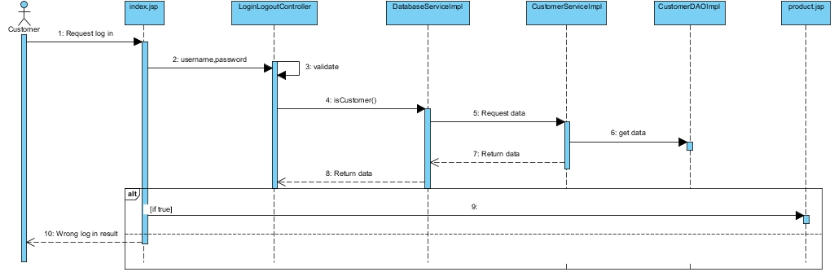

# SD-2 Register

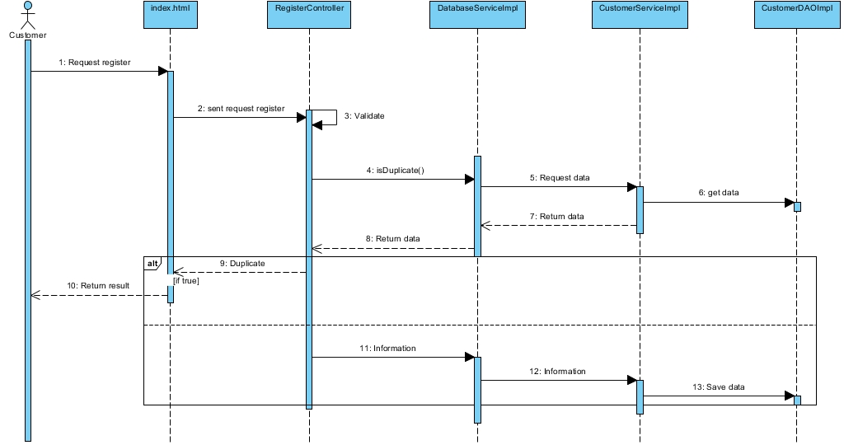

# SD-3 View all product

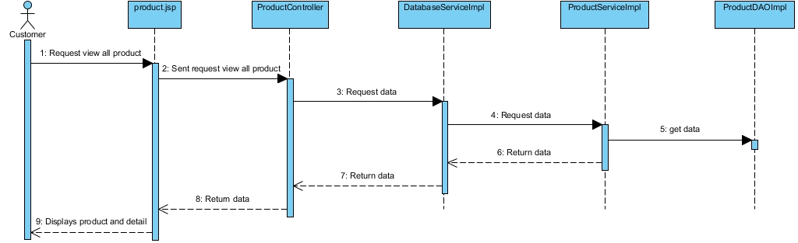

# SD-4 Select product to his/her cart

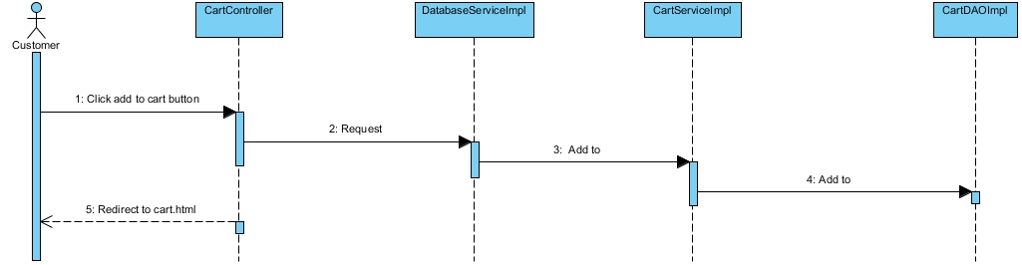

# SD-5 Remove product from cart

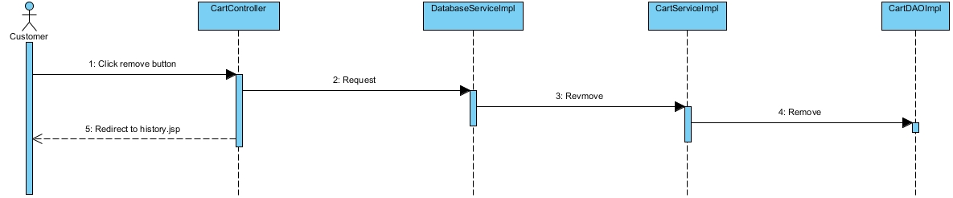

# SD-6 Add new product

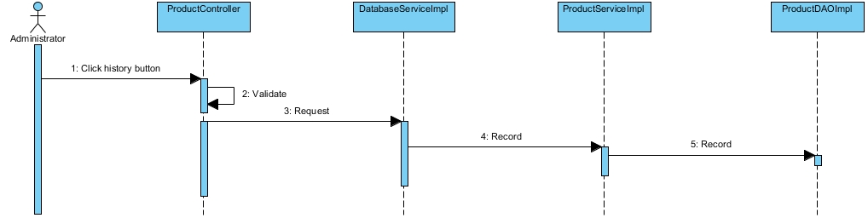

# SD-7 Search product

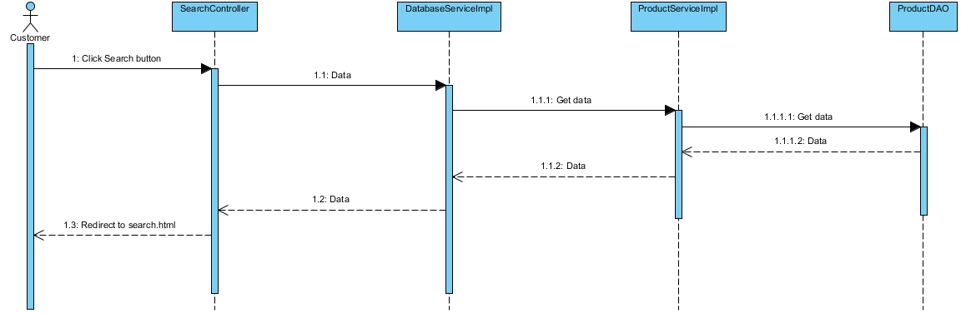

# SD-8 Check out select payment object

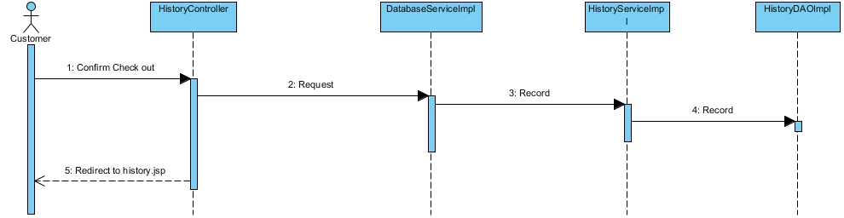

# SD-9 View his/her history

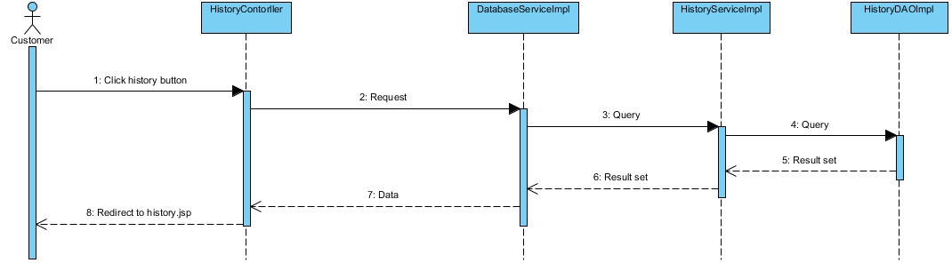

# SD-10 View all shopping history

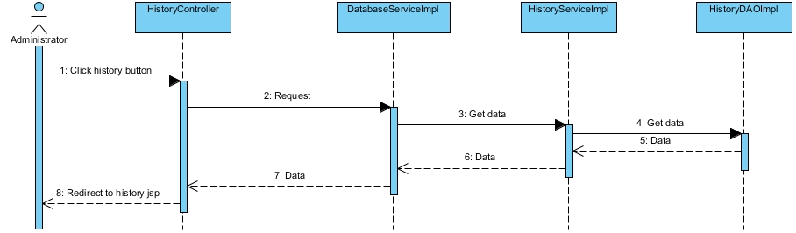

# SD-11 Update his/her information

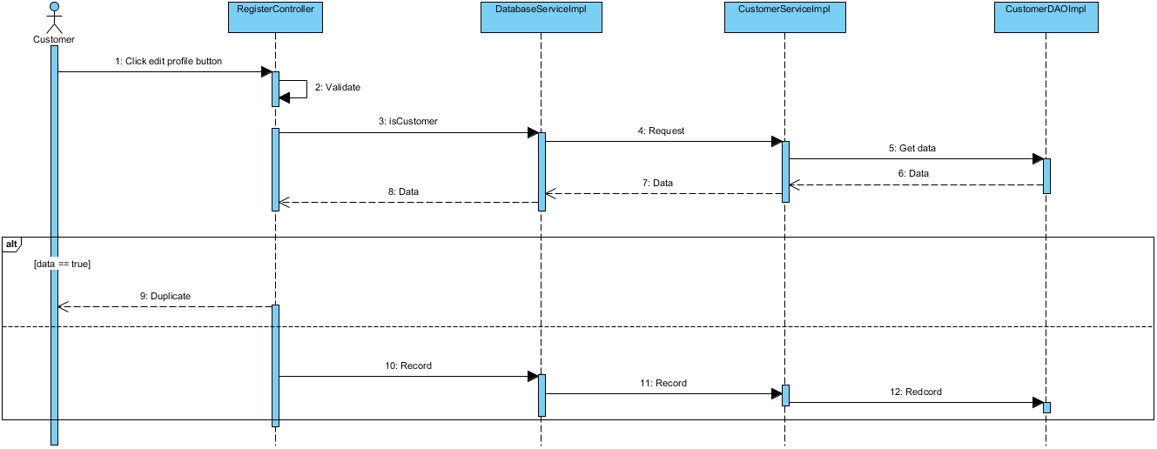

# SD-12 Log out

